NO. 3

GRAPH:

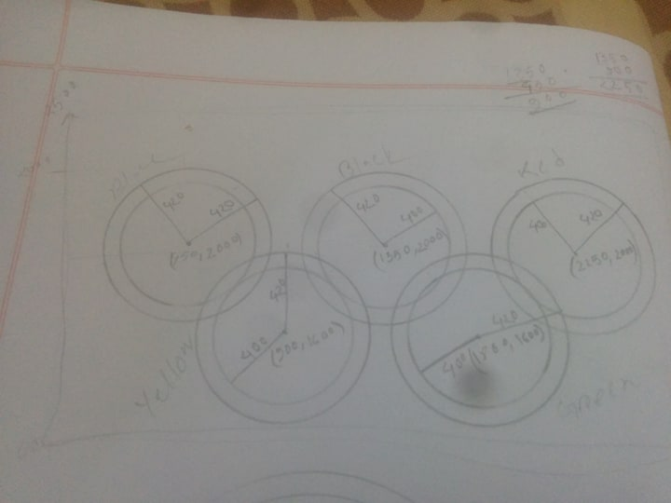

CODE:

#include<windows.h>

#include <GL/glut.h>

#include <math.h>

void init(void)

{

glClearColor(1.0, 1.0, 1.0, 0.1); // Set display window color to white

glMatrixMode(GL_PROJECTION); // Set projection parameters

gluOrtho2D(0.0, 2800.0, 0.0, 3000.0);

}

void display()

{

float theta;

int i;

glClear(GL_COLOR_BUFFER_BIT); // Clear display window

glColor3f(1.9, 1.9, 1.9);

glBegin(GL_POLYGON);

glVertex2d(0,0);

glVertex2d(2800,0);

glVertex2d(2800,3000);

glVertex2d(0,3000);

glEnd();

//blue circle

glColor3f(1.0,1.0, 1.0);

glBegin(GL_POLYGON);

for(i=0;i<360;i++) // white circle

{

theta=i*3.142/180;

glVertex2f(450+420*cos(theta),2000+420*sin(theta));

}

glEnd();

glColor3f(0.0,0.0,.9);

glBegin(GL_POLYGON);

for(i=0;i<360;i++) // blue 1

{

theta=i*3.142/180;

glVertex2f(450+400*cos(theta),2000+400*sin(theta));

}

glEnd();

glColor3f(1.0,1.0, 1.0);

glBegin(GL_POLYGON);

for(i=0;i<360;i++) // white circle

{

theta=i*3.142/180;

glVertex2f(450+350*cos(theta),2000+350*sin(theta));

}

glEnd();

// yellow circle

glColor3f(1.0,1.0, 1.0);

glBegin(GL_POLYGON);

for(i=0;i<360;i++) // white circle

{

theta=i*3.142/180;

glVertex2f(900+420*cos(theta),1600+420*sin(theta));

}

glEnd();

glColor3f(1.0,.6,.0);

glBegin(GL_POLYGON);

for(i=0;i<360;i++) // yello4

{

theta=i*3.142/180;

glVertex2f(900+400*cos(theta),1600+400*sin(theta));

}

glEnd();

glColor3f(1.0,1.0, 1.0);

glBegin(GL_POLYGON);

for(i=0;i<360;i++) // white circle

{

theta=i*3.142/180;

glVertex2f(900+350*cos(theta),1600+350*sin(theta));

}

glEnd();

// black circle

glColor3f(1.0,1.0, 1.0);

glBegin(GL_POLYGON);

for(i=0;i<360;i++) // white circle

{

theta=i*3.142/180;

glVertex2f(1350+420*cos(theta),2000+420*sin(theta));

}

glEnd();

glColor3f(0.0,0.0,.0);

glBegin(GL_POLYGON);//black 2

for(i=0;i<360;i++) // white circle

{

theta=i*3.142/180;

glVertex2f(1350+400*cos(theta),2000+400*sin(theta));

}

glEnd();

glColor3f(1.0,1.0, 1.0);

glBegin(GL_POLYGON);

for(i=0;i<360;i++) // white circle

{

theta=i*3.142/180;

glVertex2f(1350+350*cos(theta),2000+350*sin(theta));

}

glEnd();

// green circle

glColor3f(1.0,1.0, 1.0);

glBegin(GL_POLYGON);

for(i=0;i<360;i++) // white circle

{

theta=i*3.142/180;

glVertex2f(1800+420*cos(theta),1600+420*sin(theta));

}

glEnd();

glColor3f(0.0,1.0,.0);

glBegin(GL_POLYGON);

for(i=0;i<360;i++) // green

{

theta=i*3.142/180;

glVertex2f(1800+400*cos(theta),1600+400*sin(theta));

}

glEnd();

glColor3f(1.0,1.0, 1.0);

glBegin(GL_POLYGON);

for(i=0;i<360;i++) // white circle

{

theta=i*3.142/180;

glVertex2f(1800+350*cos(theta),1600+350*sin(theta));

}

glEnd();

//red circle

glColor3f(1.0,1.0, 1.0);

glBegin(GL_POLYGON);

for(i=0;i<360;i++) // white circle

{

theta=i*3.142/180;

glVertex2f(2250+420*cos(theta),2000+420*sin(theta));

}

glEnd();

glColor3f(1.0,0.0,.0);

glBegin(GL_POLYGON);

for(i=0;i<360;i++) // red 3

{

theta=i*3.142/180;

glVertex2f(2250+400*cos(theta),2000+400*sin(theta));

}

glEnd();

glColor3f(1.0,1.0, 1.0);

glBegin(GL_POLYGON);

for(i=0;i<360;i++) // white circle

{

theta=i*3.142/180;

glVertex2f(2250+350*cos(theta),2000+350*sin(theta));

}

glEnd();

glFlush();

}

int main(int argc, char* argv[])

{

glutInit(&argc, argv);

glutInitDisplayMode(GLUT_SINGLE|GLUT_RGB);

glutInitWindowPosition(100, 100);

glutInitWindowSize(350, 350);

glutCreateWindow("Iffat Firozy Rimi 163-15-8432`");

init();

glutDisplayFunc(display);

glutMainLoop();

return 0;

}

OUTPUT:

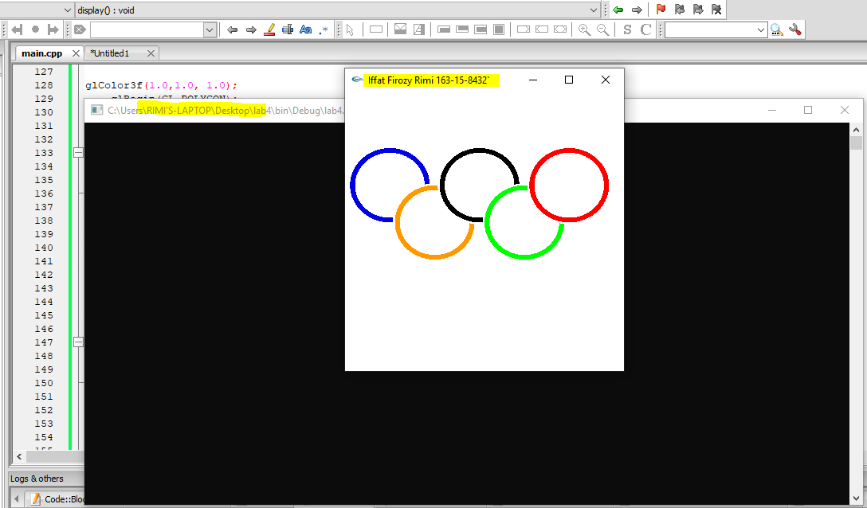

NO. 2:

Graph: 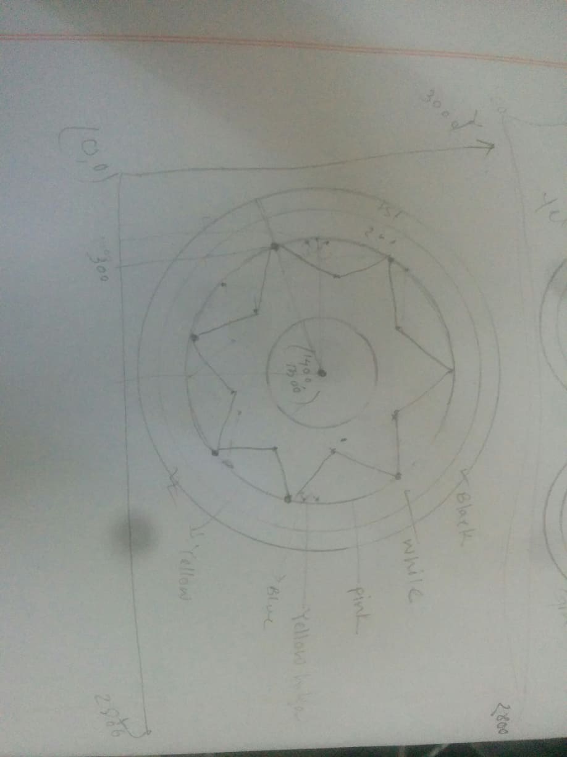

Code:

#include<windows.h>

#include <GL/glut.h>

#include <math.h>

void init(void)

{

glClearColor(1.0, 1.0, 1.0, 0.1); // Set display window color to white

glMatrixMode(GL_PROJECTION); // Set projection parameters

gluOrtho2D(0.0, 500.0, 0.0, 400.0);

}

void display()

{

float theta;

int i;

glClear(GL_COLOR_BUFFER_BIT); // Clear display window

glColor3f(.9, .9, .9);

glBegin(GL_POLYGON);

glVertex2d(0,0);

glVertex2d(500,0);

glVertex2d(500,400);

glVertex2d(0,400);

glEnd();

//black circle

glColor3f(0.2, 0.2, 0.2);

glBegin(GL_POLYGON);

for(i=0;i<360;i++)

{

theta=i*3.142/180;

glVertex2f(250+150*cos(theta),200+150*sin(theta)); // here (250,250) is the center and 150 is the radius

}

glEnd();

//white circle

glColor3f(1.0, 1.0, 1.0);

glBegin(GL_POLYGON);

for(i=0;i<360;i++)

{

theta=i*3.142/180;

glVertex2f(250+130*cos(theta),200+130*sin(theta)); // here (250,250) is the center and 150 is the radius

}

glEnd();

//black border

glColor3f(0.0,0.0, 0.0);

glBegin(GL_POLYGON);

for(i=0;i<360;i++)

{

theta=i*3.142/180;

glVertex2f(250+125*cos(theta),200+125*sin(theta));

}

glEnd();

//pink circle

glColor3f(1.0,.6, .6);

glBegin(GL_POLYGON);

for(i=0;i<360;i++)

{

theta=i*3.142/180;

glVertex2f(250+120*cos(theta),200+120*sin(theta)); // here (250,250) is the center and 150 is the radius

}

glEnd();

//outer star

glColor3f(1.0,1., .4);

glBegin(GL_POLYGON);

glVertex2i(166, 210);

glVertex2i(146, 264);

glVertex2i(200, 264);

glVertex2i(250, 304);

glVertex2i(300, 264);

glVertex2i(354, 264);

glVertex2i(334, 210);

glVertex2i(364, 170);

glVertex2i(334, 150);

glVertex2i(334, 116);

glVertex2i(250, 136);

glVertex2i(166, 116);

glVertex2i(186, 130);

glVertex2i(136, 180);

glEnd();

//inner star

glColor3f(0.2, 0.7, 1.0);

glBegin(GL_POLYGON);

glVertex2i(170, 210);

glVertex2i(150, 260);

glVertex2i(200, 260);

glVertex2i(250, 300);

glVertex2i(300, 260);

glVertex2i(350, 260);

glVertex2i(330, 210);

glVertex2i(360, 170);

glVertex2i(330, 150);

glVertex2i(330, 120);

glVertex2i(250, 140);

glVertex2i(170, 120);

glVertex2i(200, 130);

glVertex2i(140, 180);

glEnd();

//yellow circle

glColor3f(1.0,.8, .0);

glBegin(GL_POLYGON);

for(i=0;i<360;i++)

{

theta=i*3.142/180;

glVertex2f(250+50*cos(theta),200+50*sin(theta)); // here (250,250) is the center and 150 is the radius

}

glEnd();

glFlush();

}

int main(int argc, char* argv[])

{

glutInit(&argc, argv);

glutInitDisplayMode(GLUT_SINGLE|GLUT_RGB);

glutInitWindowPosition(100, 100);

glutInitWindowSize(350, 350);

glutCreateWindow("Iffat Firozy Rimi 163-15-8432`");

init();

glutDisplayFunc(display);

glutMainLoop();

return 0;

}

Output:

